GALAN, Irick Marvin A.

PLD-007-CpE11S1

Exercise #1

**What is a computer?**

A computer is a type of machinery run by complex programmed circuitry designed to interpret incoming inputs with an intention to accomplish the burden of doing a task. Computers are highly capable devices as they interpret circuit and electricity into logics enabling them to produce a result through the output devices with a given input by the user. Computers usually store and interpret the information through data processing.

**What are the essential Parts of a Computer?**

a.) **CPU (Central Processing Unit)**

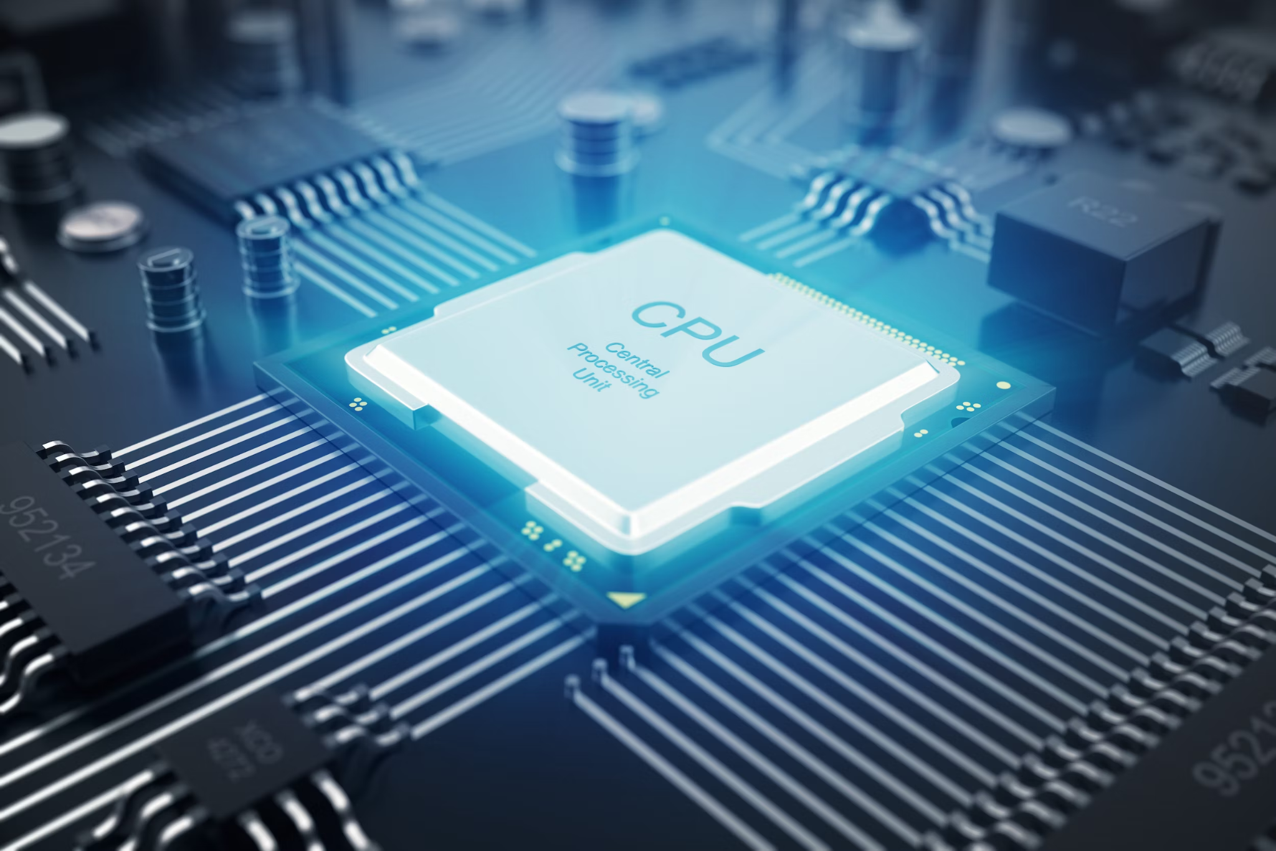

Often regarded as the brain of the computer, it handles almost all of the data processing in traditional computers, however GPU provides additional support for modern day computers depending on the demand that the task necessitates. The CPU also facilitates the computing and communication between the RAM and other hardware components of the computer.

b.) **GPU (Graphics Processing Unit)**

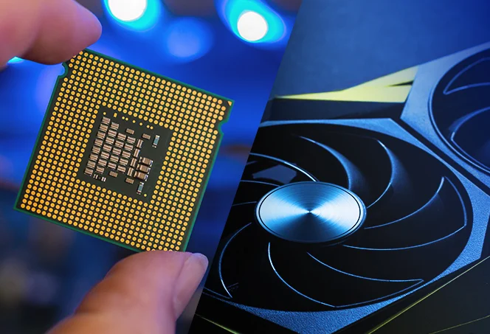

The Graphics Processor, it also functions as a bridge of monitor display for modern computers. For more complex and high quality graphics display, it also serves as a more efficient processor compared to the CPU that is always preoccupied in running most of the Operating System and its function.

c.) **Input/Output Devices**

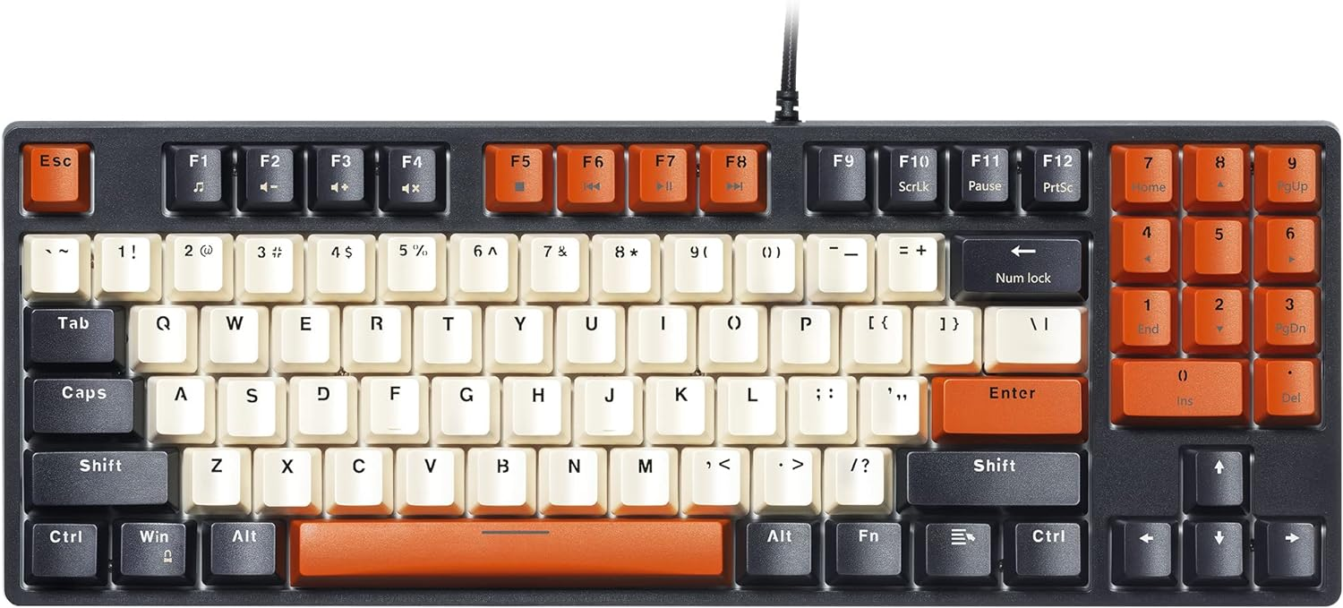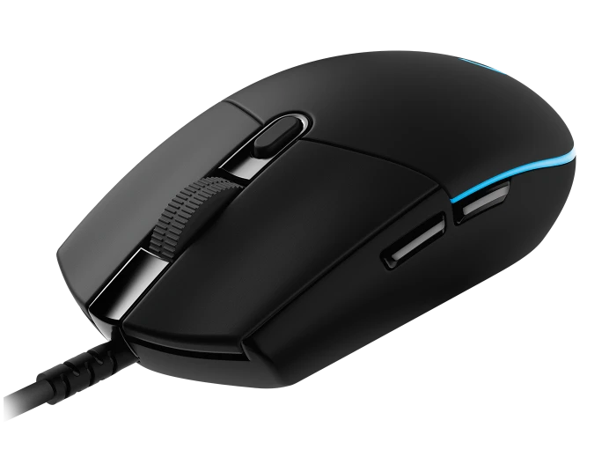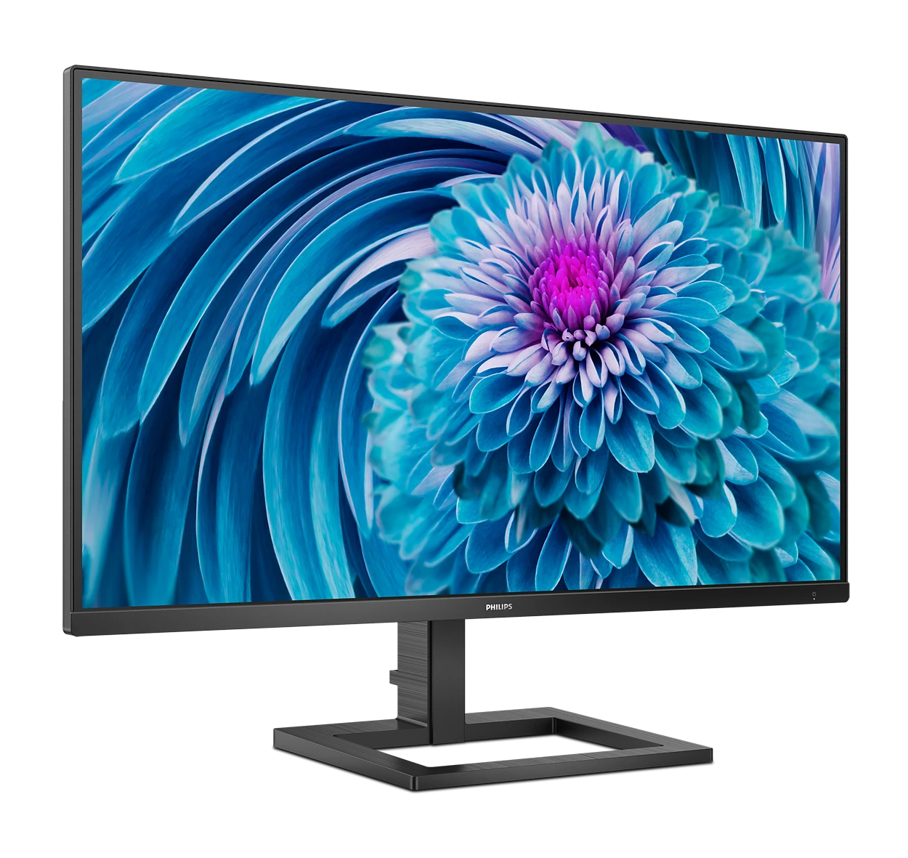

Devices such as Monitor, Mouse, Keyboard, Speakers are examples of these types of devices. Input devices serve as the means of communication from the user to the computer. Output devices are the means of communication from computer to the user, completing a seamless communication cycle between communication between the user and computer, delivering it in a language that both ends could understand and interpret. In short, these devices allow the facilitation of computer-human interaction.

d.) **Storage (Hard Drives or Solid State Drives)**

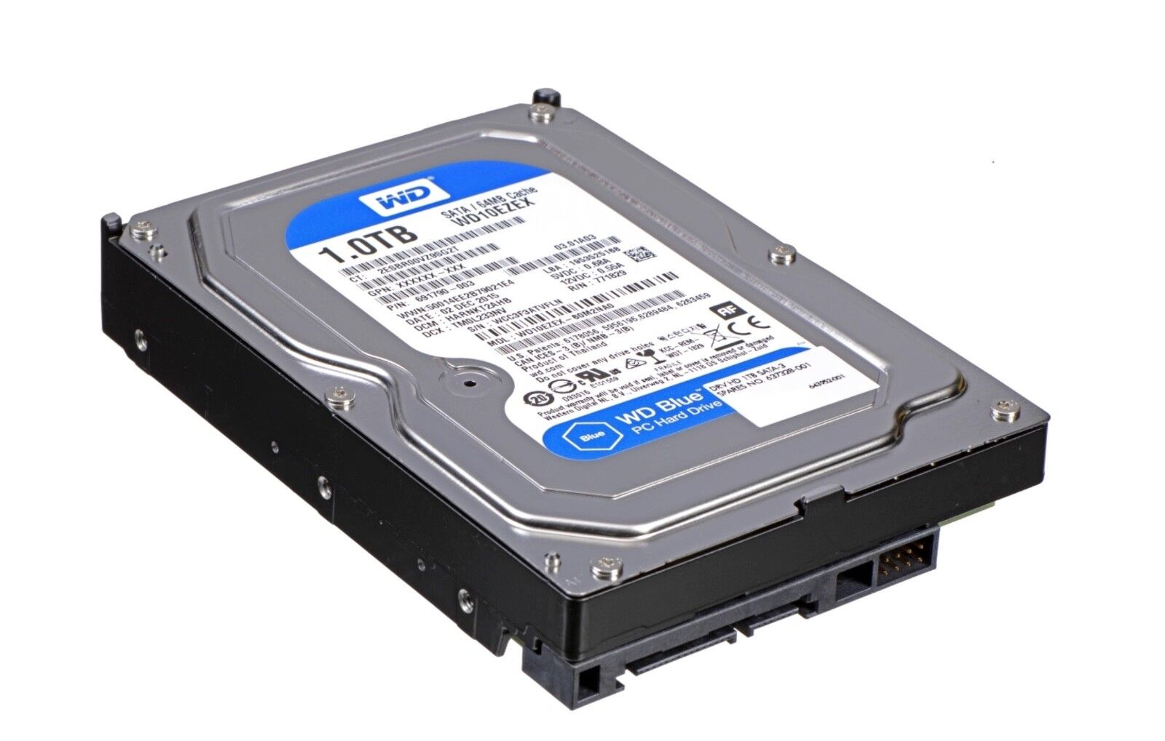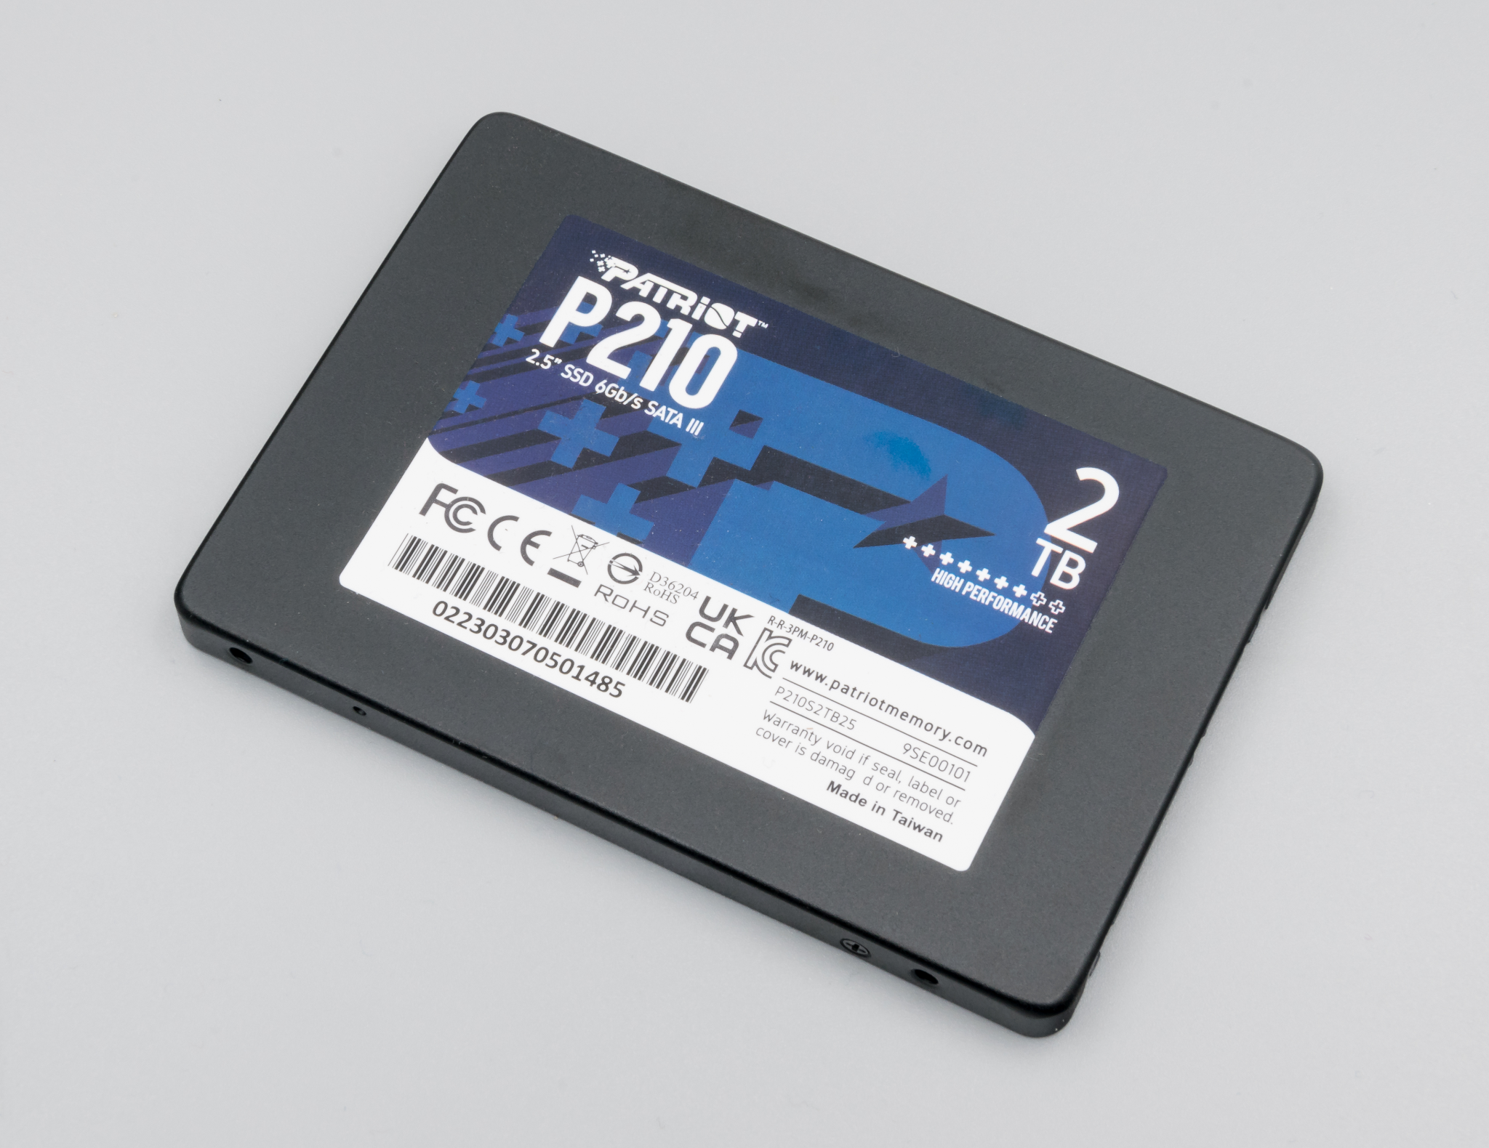

A vital component of the computer that stores the data in a long-term manner for later access and usage. It is often simplified into ROM (Read Only Memory).

c.) **RAM (Random Access Memory)**

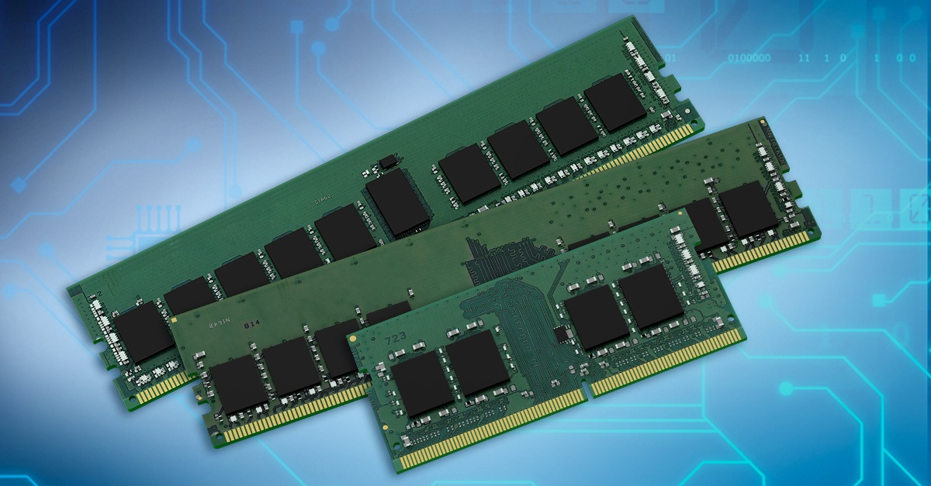

Random Access Memory is a temporary storage that is capable of running the commands of the computer through its storage. In simpler terms, it is a storage that is capable of faster processing, and storage compared to the ROM, however only for a short period of time and while the power supply is active. It communicates with other parts of the computer and therefore a computer is not capable of running without it mounted on the motherboard.

e.) **Power Supply**

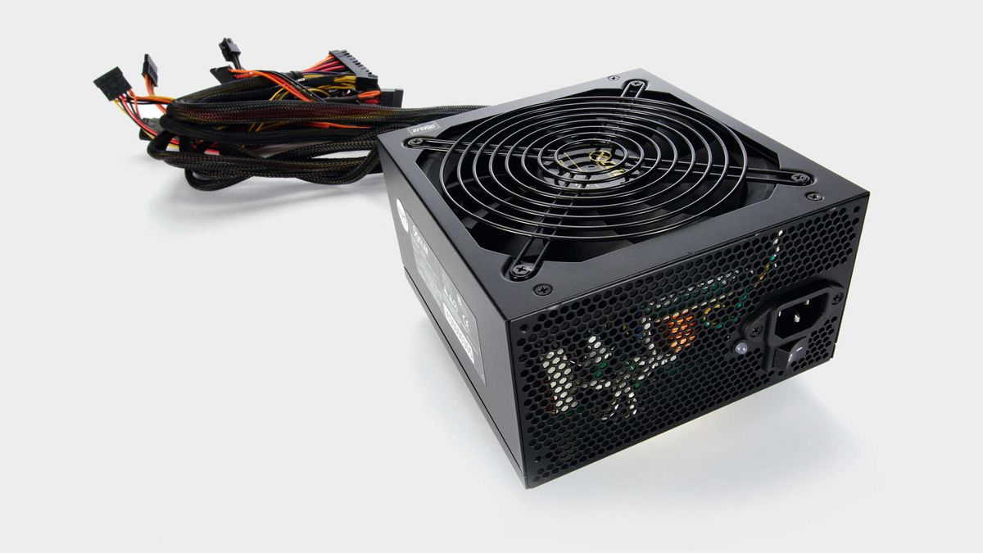

As a computer is an electrical device, the power supply provides the electrical power needed for the components of the computer to run.

f.) **Motherboard**

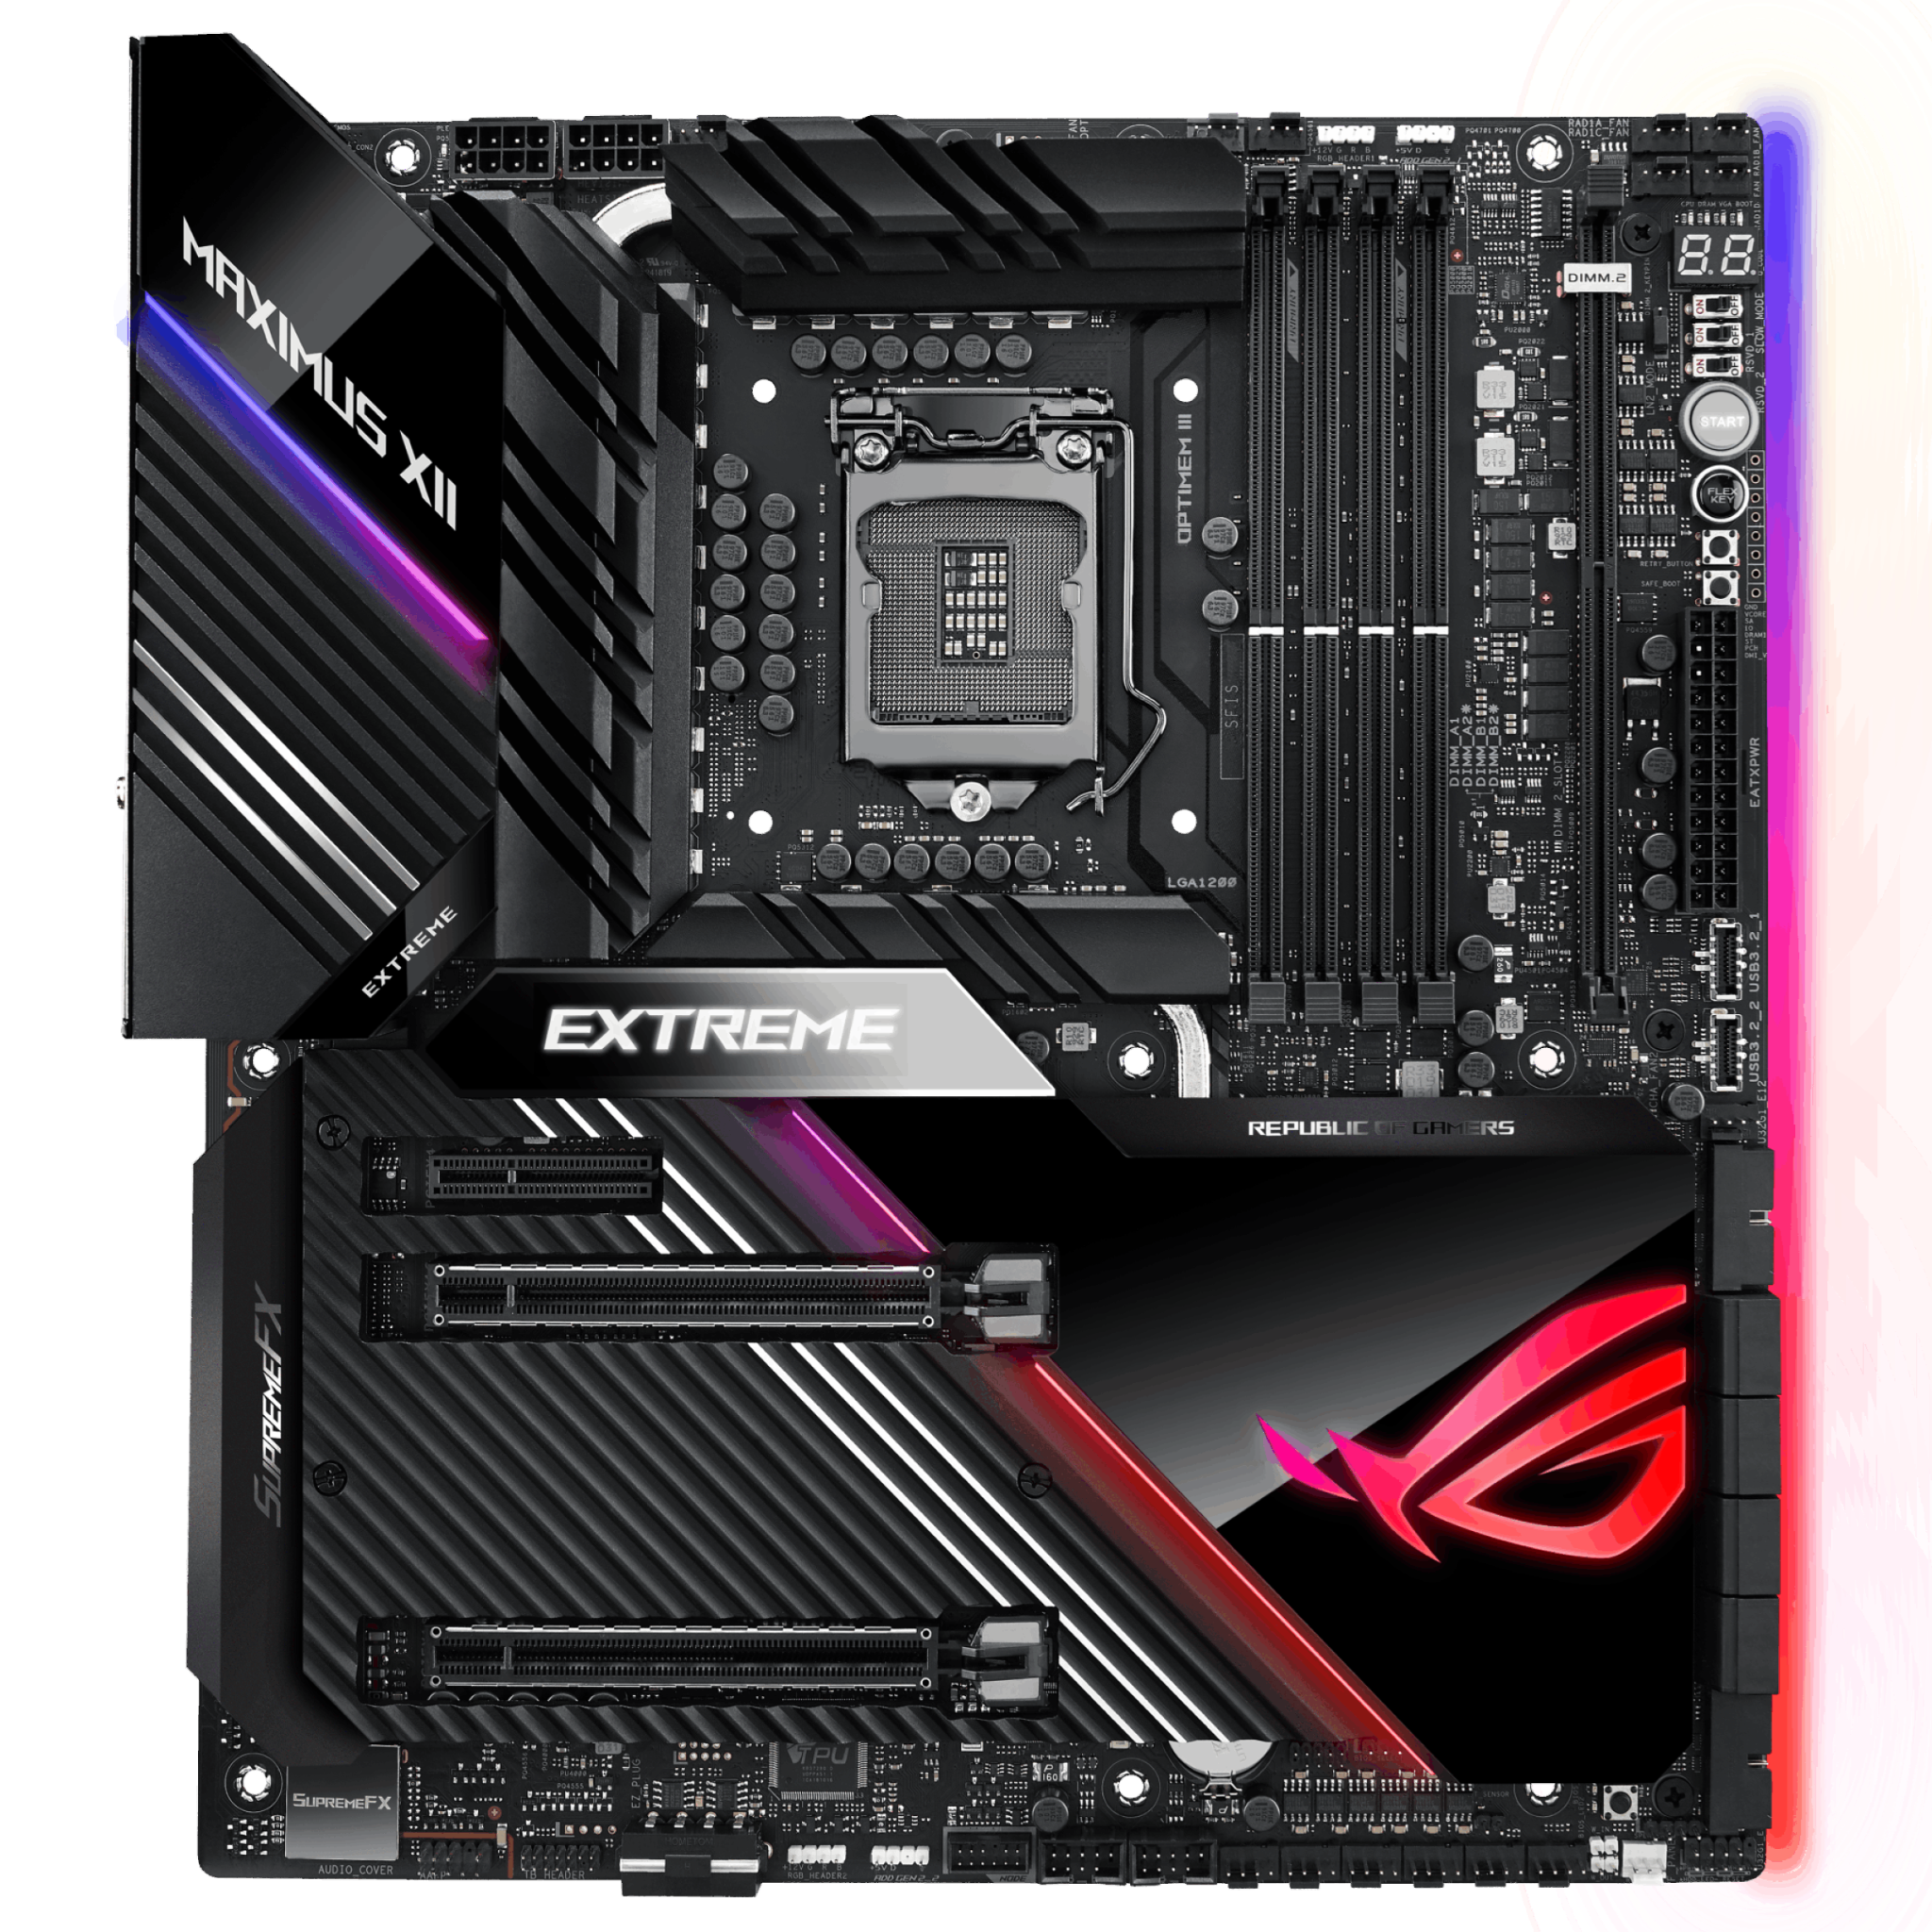

The motherboard or sometimes referred to as the mainboard, houses the other components and parts of the computer into a single board capable of facilitating communication between chips and other electrical components such as transistors and resistors.

Who are the notable inventors of hardware and software?

**Hardware Inventors:**

1. **John Vincent Atanasoff & Clifford Berry** - *Atanasoff Berry Computer* (The first electronic computer invented in 1942.)

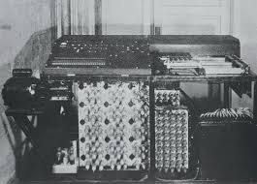

1. **Engr. Patty McHugh** - *Motherboard* (Invented in 1981 and integrated into IBM's computer under the name "Planar Breadboard".

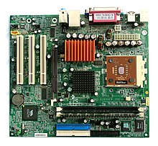

1. **Robert H. Dennard** - *DRAM* (The Dynamic Random Access Memory condensed data processing into a smaller circuit while allowing for more substantial storage.)

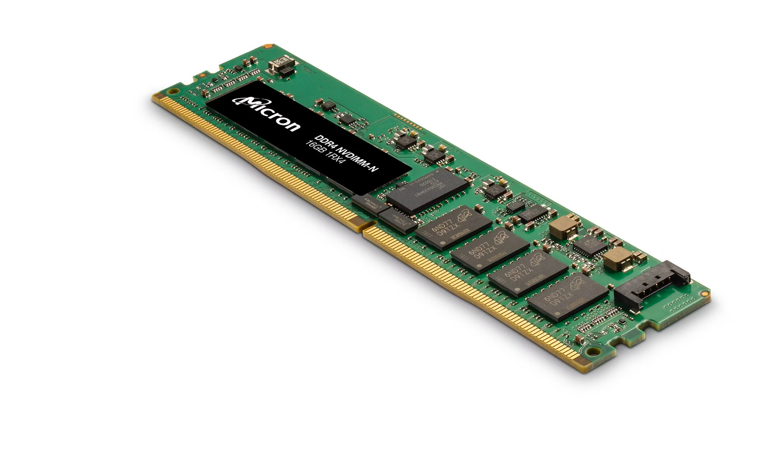

1. **Engr. Reynold B. Johnson** - *Hard Disk Drive* (The hard disk drive is the traditional storage device commonly used in older computer models that utilizes a rotating magnetic disk.)

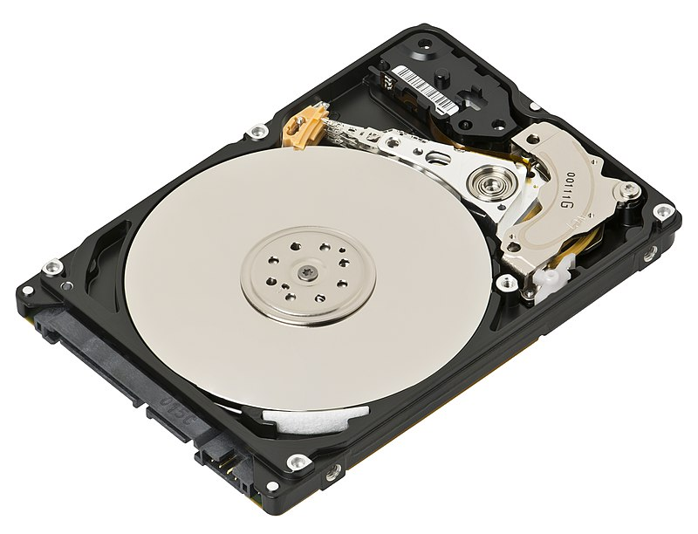

1. **Karl Ferdinand Braun** - *Cathode-Ray Tube* in 1897 (This invention contributed significantly in innovating the display technology. Cathode-Ray Tubes were used in the early late 90s and early 2000s computers.)

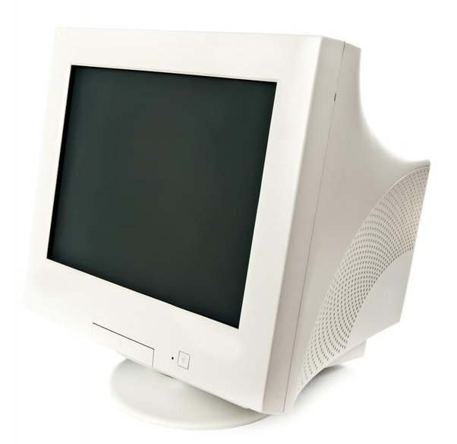

**Software Inventors:**

1. **Bob Kahn & Vint Cerf** - *TCP/IP* (Evolved the Arpanet into TCP/IP revolutionizing the data government leading to invention of the internet)
2. **Dr. Joseph Carl Robnett Licklider** - Cloud Storage (Evolved the localized hardware storages into shared storages accessed by users across through the internet.)



1. **Gary Kildall** - *BIOS* (Invented in 1975, the BIOS facilitates computer initialization and startup communication between the hardwares in the motherboard before the bootup using the storage drives.)

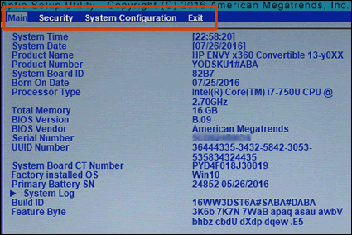

1. **George Bool** - *Boolean Algebra* (The basis of all data computing facilitating the communication of computer represented by logic and relationship of objects through numbers)
2. **Tim Berners-Lee** - *World Wide Web in 1989* (The world wide web provides an interconnected virtual space for various web pages to be linked together and to host text and multimedia interactions across users around the world through providing links usually in URL format.)

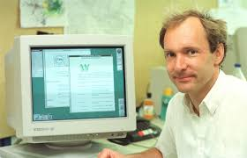

**APA Citations:**

Techspirited. (n.d.). Retrieved August 14, 2024, from https://techspirited.com/computer-inventors-their-inventions#:~:text=Famous%20Inventors%20and%20their%20Inventions%201%20Charles%20Babbage%3A,and%20Ken%20Olson%3A%20PDP%20%28Programmed%20Data%20Processor%29%20

History of the computer motherboard. (2024, August 5). Blogs - Digital Class. https://www.digitalclassworld.com/blog/history-of-motherboard/

Robert H. Dennard. (2024). National Inventors Hall of Fame® Inductee. https://www.invent.org/inductees/robert-h-dennard

Who invented the hard drive? (n.d.). Wonderopolis. https://wonderopolis.org/wonder/Who-Invented-the-Hard-Drive

Testbook. (2023, October 31). Father of Monitor – Know who invented computer monitor & How! Testbook. Retrieved August 14, 2024, from https://testbook.com/articles/father-of-monitor#:~:text=Karl%20Ferdinand%20Braun%20is%20renowned,1897%20was%20a%20game%2Dchanger.

A short history of the internet | National Science and Media Museum. (2020, December 3). National Science and Media Museum. Retrieved August 14, 2024, from https://www.scienceandmediamuseum.org.uk/objects-and-stories/short-history-internet#:~:text=BOB%20KAHN%20(1938%E2%80%93)%20AND,of%20the%20word%20'internet'.

The Investopedia Team. (2022, March 4). Cloud storage definition, benefits, Security. Investopedia. Retrieved August 14, 2024, from https://www.investopedia.com/terms/c/cloud-storage.asp#:~:text=Cloud%20storage%20is%20believed%20to,store%20some%20of%20their%20files.

BasuMallick, C. (2022, November 17). 4 Types of BIOS and Why they are so important. Spiceworks Inc. https://www.spiceworks.com/tech/devops/articles/what-is-bios/#:~:text=Gary%20Kildall%2C%20a%20U.S.%20computer,a%20fundamental%20characteristic%20of%20computers.

The Editors of Encyclopaedia Britannica. (1999, May 4). George Boole | Facts, Biography, death, Education, & Books. Encyclopedia Britannica.

https://www.britannica.com/biography/George-Boole

World Wide Web Foundation. (2020, October 8). History of the Web - World Wide Web Foundation. World Wide Web Foundation - Founded by Tim Berners-Lee, Inventor of the Web, the World Wide Web Foundation Empowers People to Bring About Positive Change. https://webfoundation.org/about/vision/history-of-the-web/